Malcolm Snyder | John Santaguida

Projects in ML – Dr. Kunda

March 27, 2017

Assignment 5

Notes on our neural network implementation of backpropagation:

We were able to achieve fairly accurate results minimizing network error as desired, shown below. However, we could not get some of the network’s extra functionality to work correctly with our algorithm, so the scope of our code currently excludes features such as mini-batches and variable hidden layer sizes. This is further documented within the comments in the source code. Besides these two things, however, our trial runs appear to be fairly optimal within the parameters of this assignment.

1. XOR problem
2. Below is shown the cost over time of our Network when fed in the XOR problem as specified.

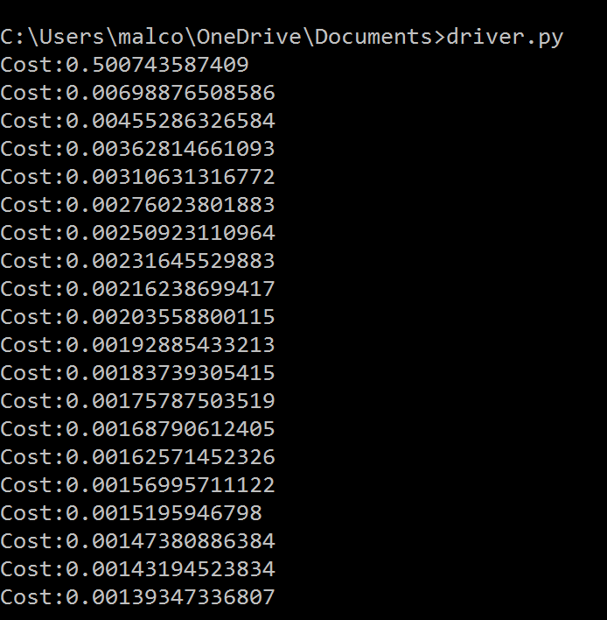

1. Below is the same trial performed, now displaying weight distributions over time.

